Setting up Users
By
Joseph Tierney

Class: Computer Science 2

Tutor: Tony Bernes

- Click Start and select Virtual Box
- Click new and set the name to Windows08
- Set for Windows Server 2008
- Set the RAM to 1024
- Create a virtual hard drive
- Select VDI (Virtual Disk Image)
- Set hard drive to dynamically allocated
- Set virtual hard drive to 25 GB
- Finish Configuration and double click Windows08
- Browse for the ISO on the desktop (Windows Server 2008)
- Install begins

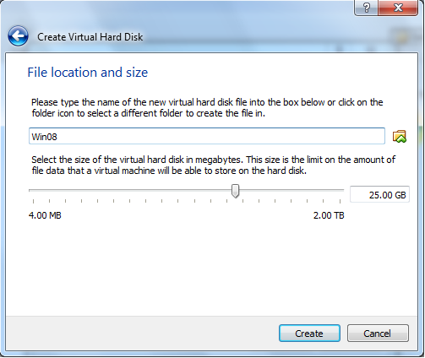

Next was setting up the IP address. To do this, open Network and Sharing Centre, and click on Local Area Connection. I then clicked on IP ver 4 and then selected properties. Set the manual address, default gateway and preferred DNS to 192.168.1.1. The subnet mask should automatically set to 255.2555.255.0

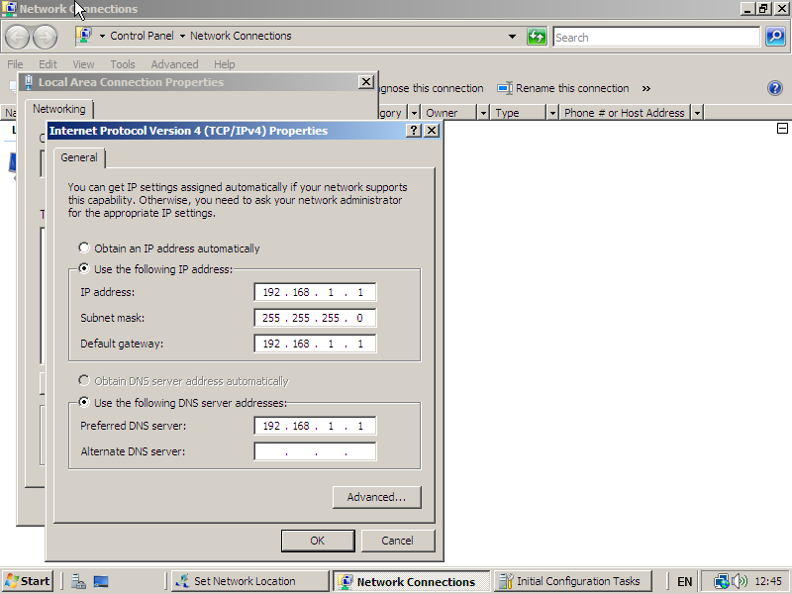

To add a user, search for dcpromo and set up a new forest. Once this was done setting up, I went to the server manager, expanded roles, expanded active directory, expanded active directory users and expanded joey.contoso.com and selected Users. From there, I right clicked and simply selected “New User”. I then created three users.

